Report by: 1409046  
Role: Level Design & Artist liaison

Game Version: Latest – with Menus  
Date Reported: 06/05/2016

QA Status: Passed

Severity: Minor

Priority: Moderate

Test Introduction:

The purpose of this test was to check that the win canvas displayed at the end of the track when the player goes through the portal. To test this, I placed the ship in front of the end zone and let the player go through.

Expected outcome:

I expected the ship to go through the portal and the win canvas to be displayed.

Actual outcome:

When the ship went through the portal the win canvas displayed for a moment, then the death canvas is displayed over the top of it, meaning the death canvas is what the player sees

Screenshot of the bug:

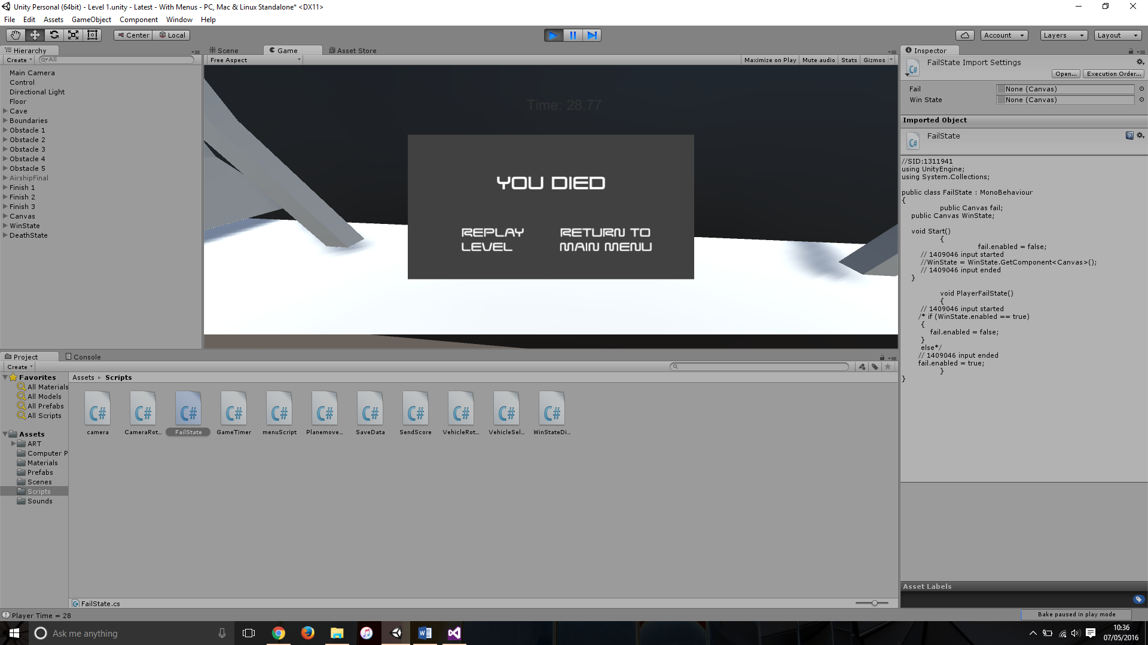

Image showing the death canvas when player is through final portal.

Potential cause:

A potential cause for this bug could be that when the ship goes through the winning portal it still crashes into the back wall, meaning that the ship still ‘dies’ after completing the game and the new canvas displays over the top.

Suggested Fix:

To fix this bug I input an ‘If’ statement which states if the win canvas is displayed then the death canvas cannot be shown.